horizontal line

**Anas Ahmed Hassan Sayed**

VR Handy Arcade

**17th September 2022**

**Github:** [AnasMations/VR-Handy-Arcade (github.com)](https://github.com/AnasMations/VR-Handy-Arcade)

# OVERVIEW

VR Handy Arcade is a game developed for the meta quest 2 devices using built-in hand-tracking feature to play through and interact with 3 different arcade games:

(Hammer cats / Ball hoops / Rolling ball).

# Scenes

1. Main menu scene where the player gets game instructions and chooses an arcade game to play.
2. Game scene containing 3 different games:
   1. **Hammer cats**: a simple game were the player grabs two hammers and starts smashing around to gain score.
   2. **Ball hoops**: a simple game like basket ball, grab physics balls and throw inside the hoops.
   3. **Rolling ball**: press arrow buttons to collect stars to gain more time and score.

# Theme

* The game setting takes place in a 90th looking arcade game hall to give a nostalgic and arcade looking feeling to the player.

## Audio

* The audio is supposed to help immerse you in the overall experience of the game by adding arcade ambiance sounds and retro-like background music.

# Graphics

* Main colors: Black, Red and Blue
* Art style: Simple looking art style

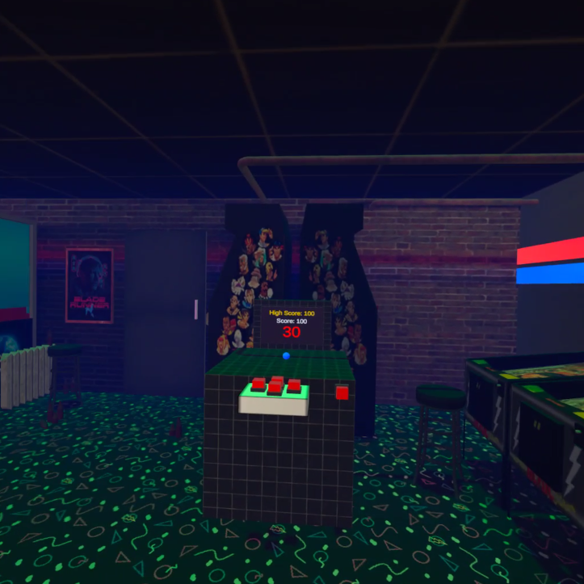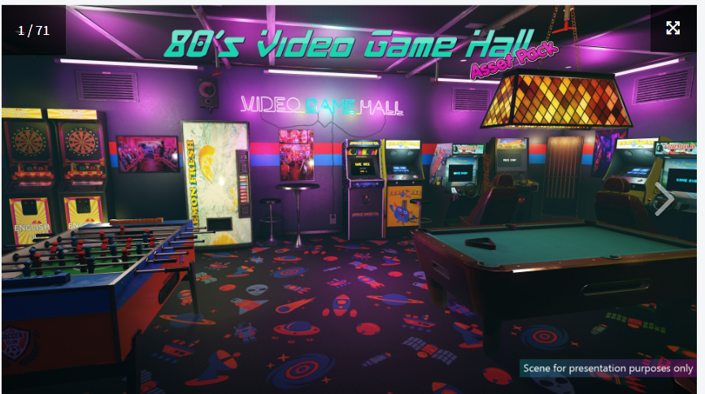

## Development

* **GameManager**.cs: to handle the game timer, score and losing conditions.
* **LevelManager**.cs: manages transition between different scenes and games.
* **AudioManager**.cs: organizes game audio and sound effects.
* **DontDestroy**.cs: script written for the AudioManager to not destroy it.
* **HammerHead**.cs: handles collision with the game hammer.
* **MazeBall**.cs: responsible for rolling ball movement and button integration
* **Star**.cs: detect collision with rolling ball.
* **StarSpawner**.cs: random star spawner with constraints.
* **Ring**.cs: detect collision with throwable ball for ball hoops game.

## Challenges

* Throwable and grabbable objects physics simulation